

***Operating systems Lab Work***

***Practical 6***

***Name :Shrey Vyas***

***Batch:F-1***

***Roll Number:22BCE335***

6A.

Code:

if [ $# -ne 2 ]

then

echo "USAGE::sh filename.sh <filename1> <filename2>"

else

if [ ! -f $1 ] && [ ! -f $2 ]

then

echo "The file names are incorrect"

else

cmp -s $1 $2

if [ $? -ne 0 ]

then

rows1=`wc -l $1 | cut -c 1 -`

rows2=`wc -l $2 | cut -c 1 -`

i=1

toggle=0

while [ $i -le $rows1 ] && [ $i -le $rows2 ]

do

str1=`head -$i $1 | tail -1 -`

str2=`head -$i $1 | tail -1 -`

if [ $str1 != $str2 ]

then

echo "The files are different at line $i"

toggle=1

break

fi

i=`expr $i + 1`

done

if [ $toggle -eq 0 ]

then

if [ $rows1 -lt $rows2 ]

then

echo "The files are the almost same but File $2 is bigger than Fi

le $1"

else

echo "The files are the almost same but File $1 is bigger than Fi

le $2"

fi

fi

else

echo "The files are exactly same."

fi

fi

fi

Output:

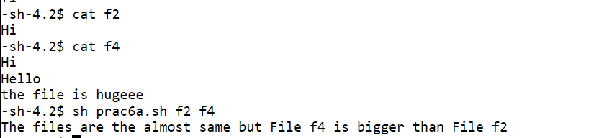

It tells at which line the files differs

6B:

Code:

if [ $# -eq 0 ]

then

echo "Not sufficient arguments for file names."

else

str=""

toggle=0

for i in $*

do

if [ ! -f $i ]

then

echo "File $i does not exist"

toggle=1

break

else

str="$str$(head $i)\n"

fi

done

if [ $toggle -eq 0 ]

then

echo -e "$str" > temp

echo "The new file is temp"

fi

fi

Output:

